LLM Memory

Rule of thumb: 16X

Now, let’s break down the memory requirements:
Parameters:
- fp16 Parameters: 2 bytes * 3B = 6GB
Gradients:
- fp16 Gradients: 2 bytes * 3B = 6GB
Activations:
- Memory required depends on batch size and context length
Optimizer States:
- fp32 Parameters: 4 bytes * 3B = 12GB
- fp32 Gradients (mean): 4 bytes * 3B = 12GB
- fp32 Gradients (variance): 4 bytes * 3B = 12GB
Total memory required = 6GB (fp16 Parameters) + 6GB (fp16 Gradients) + 12GB (fp32 Parameters) + 12GB (fp32 Gradients mean) + 12GB (fp32 Gradients variance) = 48GB
We also need to allocate some extra working memory.
Hence, to start training an LLM with 3 billion parameters, we’ll need at least 48GB of GPU memory. A simple rule of thumb to remember is that memory required is about 16 times the number of parameters.

FSDP+Activation checkpointing+DecoupledLioeW: 12X

https://github.com/mosaicml/llm-foundry/tree/main/scripts/train#how-many-gpus-do-i-need-to-train-a-llm

This is a complicated question in general, but if we assume that you are using FSDP with FULL_SHARD, activation checkpointing, and DecoupledLionW, then a good rule of thumb is:
Your total cluster memory in GB should be larger than 12 * N (# billions of params).

https://huggingface.co/docs/transformers/v4.20.1/en/perf_train_gpu_one#anatomy-of-models-memory

Numbers every LLM Developer should know
https://www.anyscale.com/blog/num-every-llm-developer-should-know

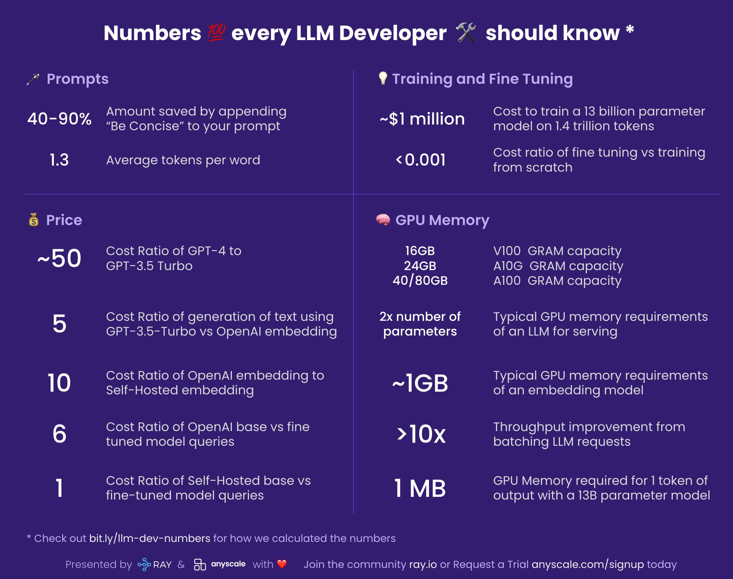

https://arxiv.org/abs/2212.14034

